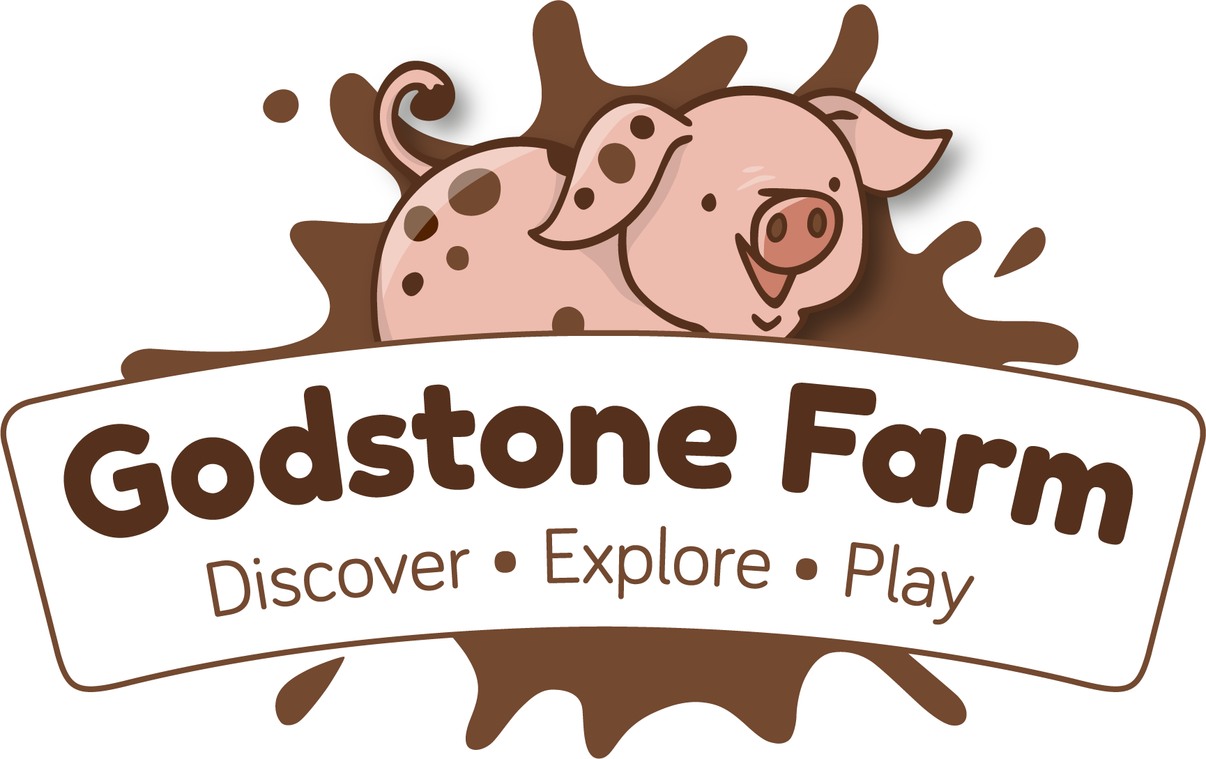

|  |  |  |
| --- | --- | --- |
| **Preschool and Reception Talks** | **Key Stage 1** | **Key Stage 2** |
| Meet the Animals | Meet the Animals | Meet the Animals |
| What is a Pig? | Pig Talk | Pig Talk |
| Barn talk | Pond Dipping (Double session) | Pond Dipping (Double session) |
| Duck Talk plus Feeding | Mini Beasts | Mini Beasts and Habitats |
| Life on the Farm-Paddock Practice | Chicken Talk | Reptiles and their Adaptations |
| Life on the Farm- Planting | Duck Talk and Feeding | Chicken Talk |
|  | Life on the Farm- Donkeys | Equine Talk |
|  | Barn Talk | Barn Talk |
|  | What makes a Seed Grow? | What makes a Seed Grow? |
| Dinosaur Walk Self-Guided Tour | Dinosaur Walk Self-Guided Tour | Dinosaur Walk Self-Guided Tour |
|  |  |  |

***Meet the Animals***

A chance to get up close to and meet the small animals. The session takes place inside the animal interactions barn, rabbit walk or on the animal interactions lawn with the chance to see, feed, and learn all about small animals including rabbits, chicks, chickens, guinea pigs and our oldest resident – George the tortoise.

***What is a pig? EYFS***

*A short introduction to what makes a pig* with the opportunity to help the farmer feed one and watch them enjoying their food. We run a successful all year-round breeding programme so will try to include piglets where possible.

***Pig Talk KS1 KS2***

A short talk on our perfect piggies and the opportunity to help the farmer feed one and to watch them enjoying their food. We run a successful all year-round breeding programme so will try to include piglets where possible.

***Duck Talk and feeding***

Head over to the pond and learn about our floating feathered friends, how they live their lives, find their food and keep warm with a layer of waterproof oil on their feathers that keeps them warm and dry. Help the farmers call our chatty ducks and fish over for a feeding session on the bridge, it’s quackers!

***Life on the Farm***

This year we are bringing you some new hands-on activities to help children understand more about the practical side of life on a farm

**Paddock practice**

Listen to a short chat about our hooved friends, then help the farmer to muck out and top up the donkeys’ paddock, looking at the role donkeys and Shetland ponies play on the farm and how to keep animals fed and healthy.

**Planting**

Come and have a look at our new schools’ garden! Try digging in our beds to see what minibeasts we can see, explore the different types of seeds we use on the farm and have a go and tending and weeding our schools farm garden.

***Pond Dipping***

Enter our gated area with 3 identification stations and jetties. Grab your net & tray, kneel on our pads and dig deep to discover the delights of our man made, Surrey Hills-fed Warren Island pond.

***Mini Beasts KS1***

Meet in our new gated Mini Beast area for your Bug Safari Booklet, pencil and magnifying glass – lift the lids on our trap doors, have a poke around in our activity tables and take a walk round the duck pond and Warren Island pond, finishing in our creature caves.

**Mini beasts and Habitats KS2**

Come and explore our minibeast garden. With your booklet and magnifying glass come and investigate a variety of minibeasts, try some hands-on classifying and explore a variety of minibeast habitats looking at adaptations.

***Chicken / Feathered Friend Chat***

Come and meet and greet our variety of feathered friends in all shapes and sizes, rheas, Chinese Geese, Guinea Fowl, peafowl, Pekin & Silkie Bantams, Warrens, Orpington, Brahmas and highly decorated Polish Chickens – the models of the chicken World.

*\*Please note that during periods of avian flu, this activity will be unavailable. An alternative activity will be offered.*

***Barn Animals Talk***

Peep into the main barn and see if you can spot our cute goat kids, some spring lambs or some gorgeous alpacas. It’s always a lovely experience to explore the Barn and hear about the wonderful animals, have a turn at milking our goat Gloria, and **new for 2023 come and help us feed our friendly sheep**

***What makes a seed grow?***

Where does our food come and why farming is so important? A session which looks at classifying a range of seeds we use here on the farm, looking at what the seeds need to grow, taking a look at how vegetables grow, plus what happens above and below the ground. Getting the beds ready and planting seeds/plants in our schools garden.

**Dinosaur Walk**

Come and explore our Dinosaur trail! Come into our woods and see if you can find our dinosaurs from the world of Dinosaur ROAR! Using our trail booklet you can follow the trail and learn all about the different dinosaurs and their different sizes, skills and bodies. Find out facts, such as how big were the teeth of a Tyrannosaurus Rex or how long was a diplodocus.

**Equine talk**

Come say hello to our donkeys and ponies. See the difference in their size and learn how to measure in ‘hands’ Take a look at their shoes, their eyes and learn more about their fantastic memory and the jobs they help us with both historically and still today! Compare and contrast the difference between the two.

**Reptiles and their adaptations**

Come and learn all about our reptiles - learn what makes a reptile and compare the difference between our bearded dragon and our leopard gecko. Look at our snakes and compare their differences in sizes, colours and the foods that they eat.

**Afternoon**

***Free Time***  
As well as the educational facilities available the farm also boasts a GIANT adventure playground, toboggan run & sandpits. Use your free time to continue to learn as you walk around the farm or let off steam after a jam-packed morning of fresh air, sights, smells and learning. Please note that entrance to the playbarn is not included in the schools visit.